** **

TEAM: **VIKAS**

**Team Members:**

1. Kunal Vasudevan (9919004153)
2. Vikrant Joilya (9919004368)
3. Ashutosh Patel (9919004378)
4. Shagun Pandey (9919004211)
5. Imam Afsar (9919004355)

* **Introduce or summarize your project’s purpose**

**Digital –Automatic Attendance System for education campus: Attendance in the education system is very important and having directly proportional to the performance of the students in most of the cases. As technology enhances day by day, it is imperative to have such a system which can reduce the time of the entire class for taking manual attendance and at the same time avoiding the problems of proxy.**

* **Objectives of the project should be well defined in a low-level design document.**

After run you need to give your face data to system so enter your ID and name in box than click on Take Images button.

It will collect 200 images of your faces, it save a images in Training Image folder

After that we need to train a model (for train a model click on Train Image button.

It will take 5-10 minutes for training (for 10 person data).

After training click on Automatic Attendance, it can fill attendance by your face using our trained model (model will save in Training Image Label)

It will create .csv file of attendance according to time & subject.

You can store data in database (install wampserver), change the DB name according to you in AMS_Run.py.

Manually Fill Attendance Button in UI is for fill a manually attendance (without face recognition), it's also create a .csv and store in a database

* **Include a short performance of some**

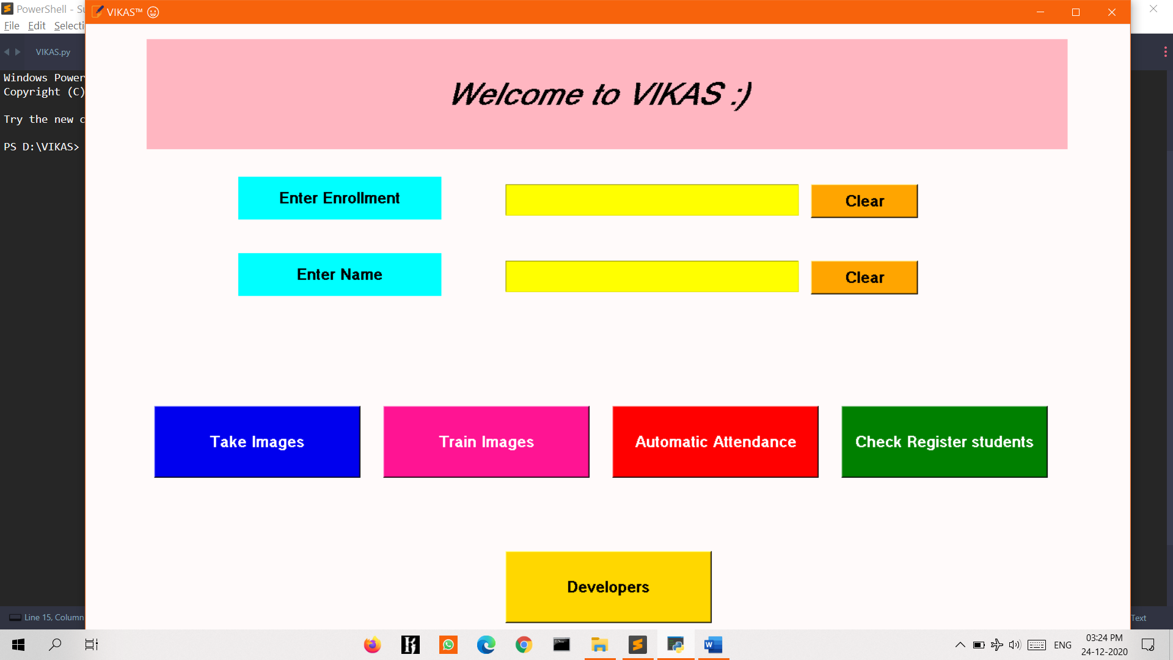

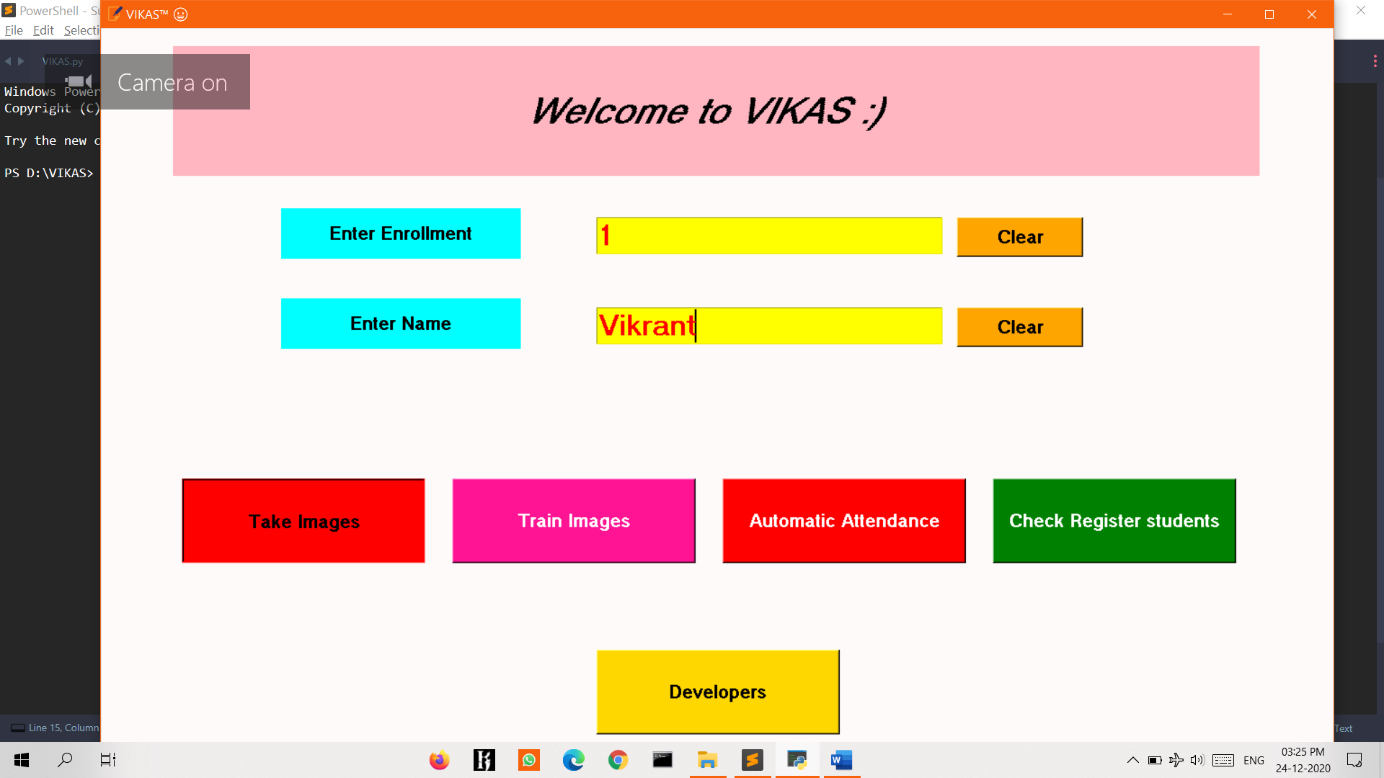

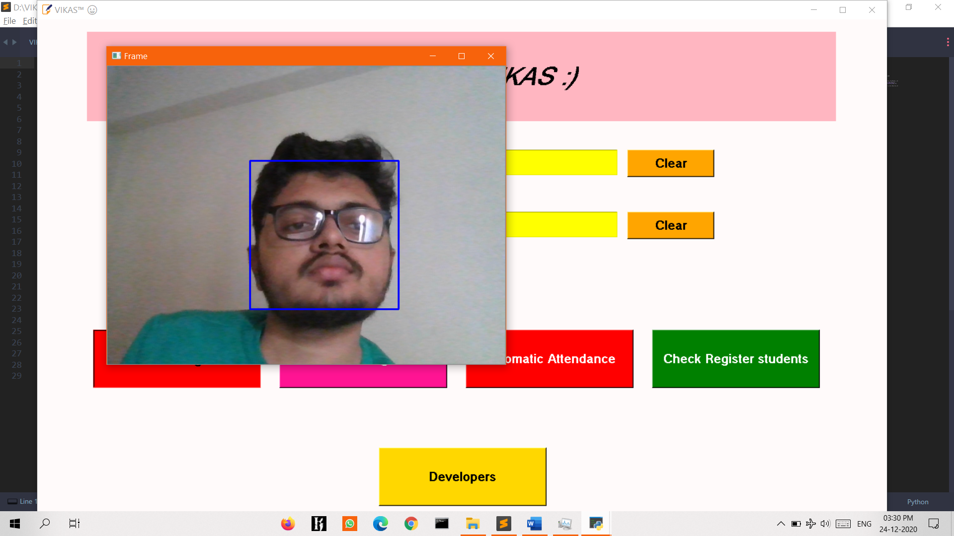

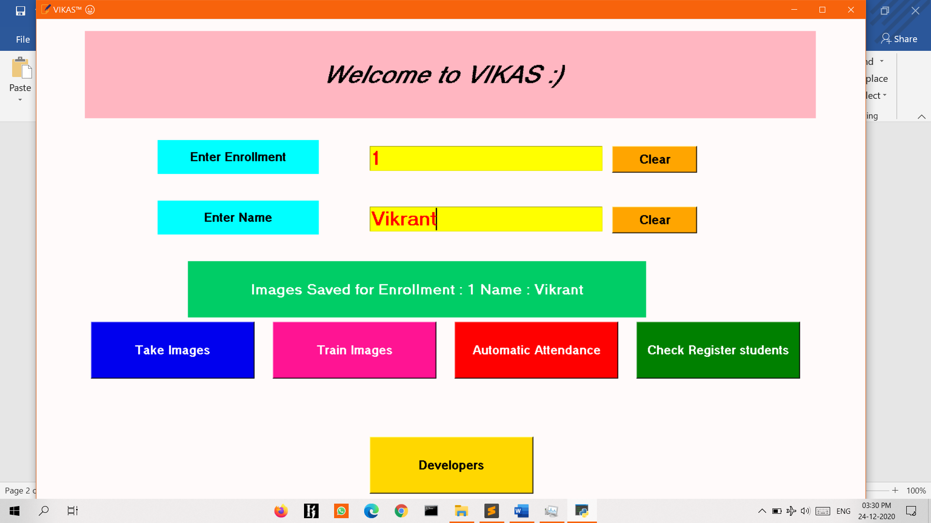

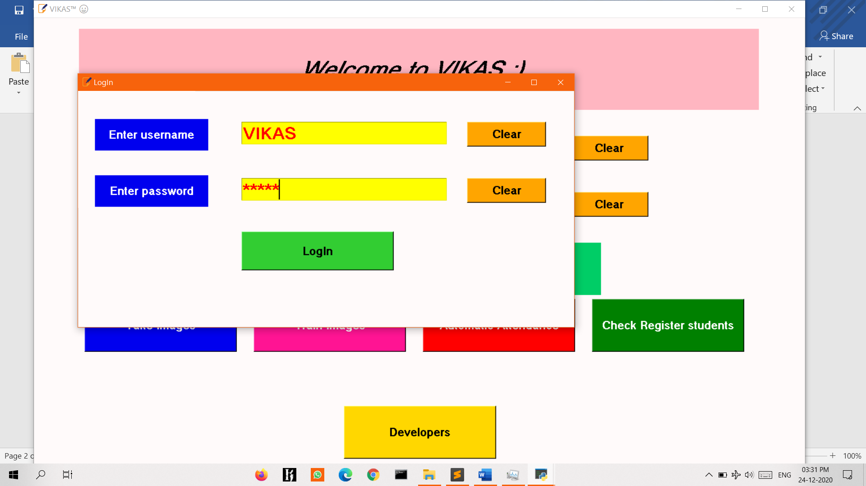

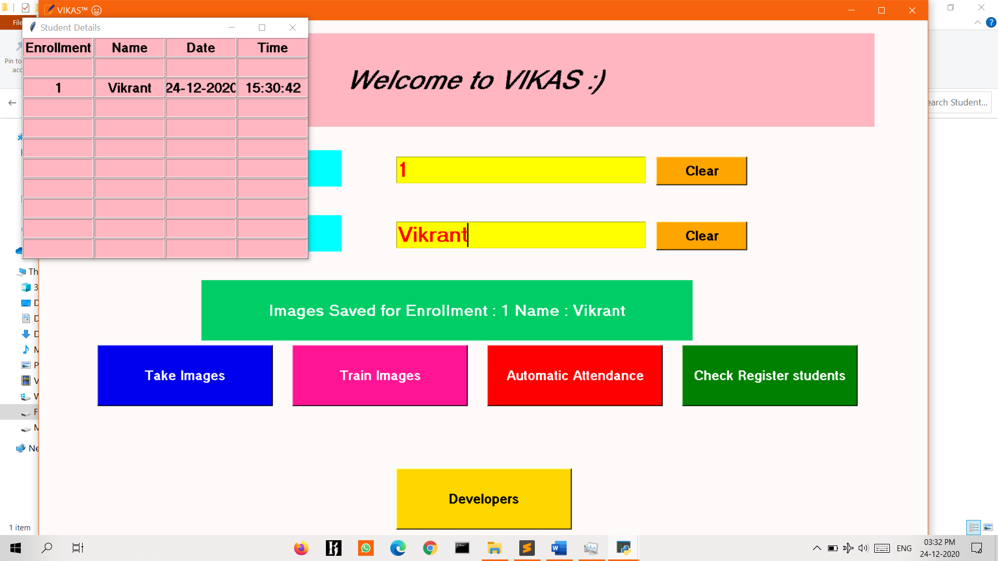

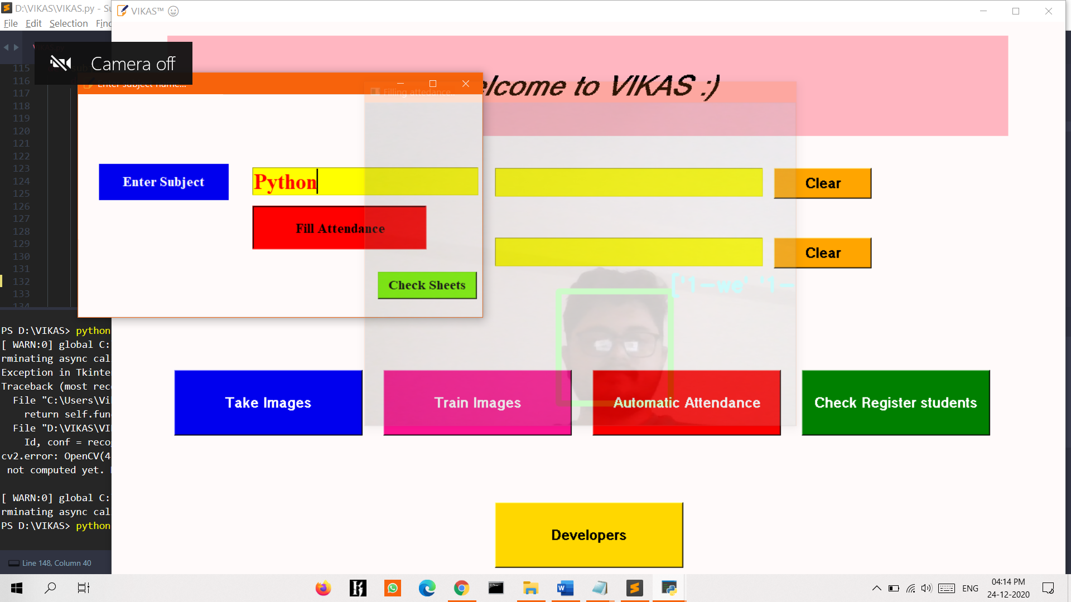

* **Description of the good or service and Needs of the product**

As now days because of pandemic all the classes and meeting are online so we need to ensure that the security and attendance should be authenticated and secure so are team thought of making an application where we can do a face recognition based attendance. In which there will be student will be registering with their Registration Id, name and on click photo of their which will be stored in the folder where the software will scan the photo and compare with the live video capturing photo if it matches then the attendance will automatically generated . Also teacher can manually take attendance in it.

* **The potential value gained by the potential customers**

We will provide our best in the quality of product and services as we our making an application so we need to ensure that there should not be any trafficking in the network and leaking of data of we would give every login college a RSA token or something like that which would help in security.

* **The value gained by all stakeholders**

As the application works properly and the big companies like google, Facebook and many more use are application then we would make the profit with advertising and other stuff which would definitely will make profit to the stakeholders and other holders.

* **The competitive advantage that can be gained by the Company**

As there are very less companies in India which provide and ensure protection to the customers, so competitive advantages can be gained by our company.

* **Profit potential and funding requirements**

As every company needs funding to start but in our project we need very less amount of funding because all the work is in our software base not in hardware base so the budget will also be less.